kazakh national university named after al-farabi

faculty of chemistry and chemical technologY
Department of physical chemistry, catalysis and petrochemistry

Methodical instructions for laboratory work
Electrical conductivity of electrolyte solutions

ON THE COURSE “PHYSICAL CHEMISTRY”

Approved at the meeting of the department of physical chemistry, catalysis and petrochemistry
dated “ ___ ” _____ 202___, protocol No. ___

Head of the department ________Ye.A. Aubakirov

- AIM OF THE WORK

The aim of the work is to study the theoretical foundations and experimental determination of the electrical conductivity of aqueous solutions of electrolytes.

- THEORETICAL POSITIONS

The ability of substances to conduct electric current is called electrical conductivity. Electrolytes, like conductors of the 1st kind (metals), have some resistance to the passage of electric current through them. This is due to the fact that each ion in the electrolyte solution is surrounded by solvent molecules and an ionic atmosphere, i.e. by ions with a charge opposite to the charge of these ions called the central one.
Under the action of an electric voltage applied to the electrodes, the electrolyte ions in the solution begin to move, i.e. an electric current flows through the solution. When moving in a solution, ions experience an inhibitory effect both from the side of the solvent molecules and from the side of the ions located near them – the ionic atmosphere. The inhibitory effect of solvent molecules in the absence of an ionic atmosphere can be likened to friction forces acting on an undeformable ball moving in a continuous viscous medium.
The inhibitory effect of the ionic atmosphere, the charge of which is opposite in sign and equal to the charge of the moving central ion, is due to the fact that when the ion moves from one point of the solution to another, the ionic atmosphere surrounding the ion at a given point dissipates and a new ionic atmosphere is formed around the ion at another point, the ions of which move towards the central ion. The process of dispersion and formation of the ionic atmosphere does not occur instantly; this requires a certain time τ, which is related to the relaxation time of the ionic atmosphere θ, i.e. the time during which the initial excess concentration of ions in the ionic atmosphere decreases by ε times (ε is the base of the natural logarithm). For electrolytes with the same ion charge (symmetric electrolytes), τ is determined by the formula:

τ = 2θ (1)

Since the formation and dispersion of the ionic atmosphere take a certain time, the center of the moving ion is displaced with respect to the center of the ionic atmosphere. In this case, an electrostatic effect arises between the ionic atmosphere and the central ion, which leads to a decrease in the speed of the latter, and this effect is called relaxation.
In addition, when ions move in one direction, ions of the ionic atmosphere of the opposite sign move towards it, which carry solvent molecules with them, as if creating a solvent flow towards the moving ion, which causes an additional inhibitory effect on the movement of the ion, which is called the electrophoretic effect.
The effects that slow down the movement of ions depend on the concentration of the solution, which affects the structure of atmospheric ions, and in general cause the resistance of the electrolyte solution.
The resistance of the electrolyte solution R is directly proportional to the interelectrode distance (l) and inversely proportional to its cross-section (S):

R=ρ$\frac{l}{S}$ (2)

where ρ is the proportionality coefficient, which depends on the nature of the electrolyte solution and is called its resistivity.
The reciprocal of resistance is called electrical conductivity (L) and is measured in Ohm⁻¹:

L = $\frac{1}{R}$ (3)

An important characteristic of electrical conductivity is the specific electrical conductivity χ, which is estimated by the relation:

$χ=\frac{l}{ρ}$ (4)

The physical meaning of χ in the SI system is defined as the electrical conductivity of the volume of an electrolyte solution enclosed between two parallel electrodes with an area of 1 m² at a distance of 1 m; its dimension is Ohm^{-1.}m⁻¹ or S.m⁻¹, where Ohm⁻¹= S (S – Siemens).
In practice, it is very difficult to measure the values of l and S when determining the specific electrical conductivity of solutions (formula 2). However, the ratio 1/S can be easily determined by measuring the resistance of a solution which electrical conductivity is known. The ratio 1/S is called the cell constant and is denoted by K. Then

$$\frac{l}{S}=\frac{R}{ρ}=Rχ=К$$

The constant cell shows how many times the resistance of the solution column between the electrodes is greater or less than the resistivity. Once the value of the cell constant has been determined, it is necessary to ensure that the electrodes do not move and the cover of platinum black is not disturbed, because this may change its value.
The specific electrical conductivity of solutions depends on their concentration (Fig. 1). At low concentrations of solutions, the number of ions in 1 cm³ solution is small and, since the current is carried by ions, the specific electrical conductivity of the solutions is low. As the concentration increases, the number of ions in 1 cm³ of solution also increases, and, accordingly, the electrical conductivity increases. However, when a certain solution concentration is reached, the electrical conductivity begins to decrease in the case of strong electrolytes due to increased ion deceleration due to relaxation and electrophoretic effects, and in the case of weak electrolytes, due to a decrease in the degree of dissociation.

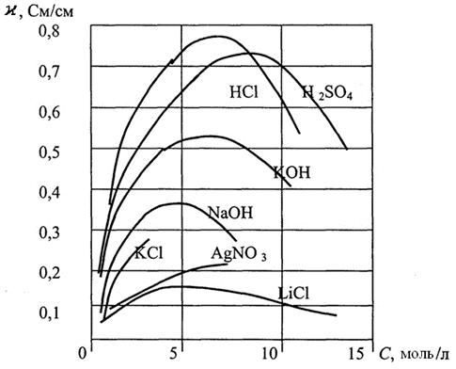

Fig.1. Dependence of electrical conductivity on concentration for
various electrolytes

Since the electrical conductivity of electrolytes is due to the movement of ions in a solution, the value of the specific electrical conductivity is determined at a constant valency of the ions by their speed of movement, the concentration of the solution, and the temperature. The dependence of electrical conductivity on temperature is described by the equation:

χ_{t} = χ₁₈ [1+α(t-18)] (5)

where χ_{t} is the specific electrical conductivity of the electrolyte at a temperature t;
χ₁₈ is the specific electrical conductivity of the electrolyte at 18 ºС;
α is the temperature coefficient.
For a binary one-univalent strong electrolyte at a constant temperature, the dependence of electrical conductivity on electrolyte concentration is expressed by the equation:

χ = $\frac{С_{i}F(u_{k}+u_{a})}{1000}$ (6)

where F is the Faraday number;
C_{i} is a concentration of the solution, g-eq/l;
u_{c} and u_{a} are absolute rates of cations and anions at a potential gradient of 1 V/cm.
This equation is usually written in the form:

χ = $\frac{С_{i}}{1000}$($λ_{к}+λ_{α}$) (7)

where λ_{c} = F.u_{c}, λ_{a} = F.u_{a} are values called cation and anion mobilities.
The dependence of the electrical conductivity on the electrolyte concentration turns out to be much more complex than can be concluded from equation (6), since the ion mobility changes with the concentration.
According to the theory of strong electrolytes, equation (7) should be written as follows:

χ=$\frac{C_{i}ʄ_{λ}}{1000}(λ_{k}+λ_{a})$ (8)

where ʄ_{λ} is the coefficient of electrical conductivity.
In case of weak electrolytes:

χ=$\frac{C_{i}α_{λ}}{1000}(λ_{k}+λ_{a})$ (9)

where α_{i} is the degree of dissociation.
In electrochemistry, the concept of equivalent (or molar electrical conductivity, if the electrolyte concentration is expressed in mol/l) electrical conductivity, first introduced by R. Lenz, is often used.
Equivalent (molar) electrical conductivity (λ_{V}) is the electrical conductivity of 1 g-eq (or mol) of a dissolved electrolyte placed between electrodes located at a distance of 1 m.
Obviously, at a given concentration, the equivalent electrical conductivity is expressed as follows (Fig. 2):

$λ_{C}=\frac{χ}{C_{i}}×1000$ (10)
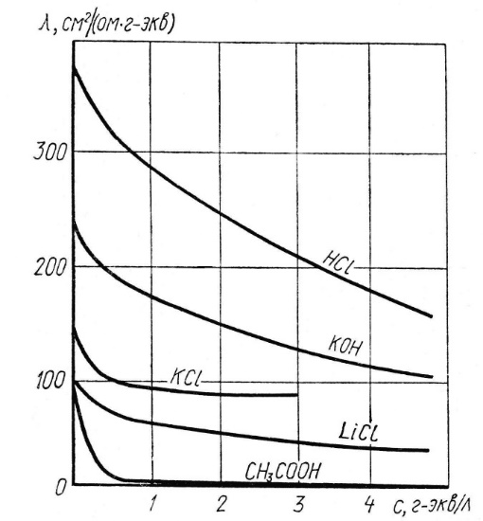

Fig.2. Dependence of equivalent electrical conductivity on concentration for various electrolytes

or $λ_{V}=χ×1000×ν$

where ν is solution dilution (Fig. 3)

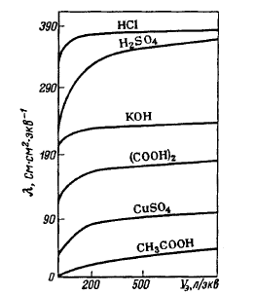

Fig.3. Dependence of equivalent electrical conductivity on dilution
for various electrolytes

$λ_{C}=ʄ_{λ}(λ_{k}+λ_{a})$ (11)

At an infinite dilution of the solution, the electrical conductivity coefficient approaches to unity, i.e.

$λ_{∞}=λ_{k,∞}+λ_{a,∞}$ (12)

where $λ_{∞}$ is equivalent electrical conductivity of an electrolyte at infinite dilution;
$λ_{k,∞} and λ_{a,∞}$ are mobility of ions in an infinitely dilute solution.
Then for strong electrolytes:

$ʄ_{λ}=\frac{λ_{C}}{λ_{∞}}$ (13)

Similarly, according to equation (9) for weak electrolytes:

$α=\frac{λ_{C}}{λ_{∞}}$ (14)

The relationship between λ and χ from equation (10) may vary depending on the choice of concentration units, if λ is expressed in S.m²/mol, χ is S/M, dilution is m³/mol, C is mol/m³, then in general form λ=χ/С.
The dependence of the equivalent electrical conductivity on temperature is expressed by an equation similar to equation (5), since the equivalent electrical conductivity is directly proportional to the specific one, and is written as follows:

$λ_{t}=λ_{18}[1+α(t-18)]$ (15)

The dependence of the equivalent electrical conductivity on the solution concentration also turns out to be complex, but for not very concentrated solutions of binary strong electrolytes, it often obeys one of the following empirical equations:

$λ_{C}=λ_{∞}-A\sqrt{C}$ (16)
$λ_{C}=λ_{∞}-B\sqrt[3]{C}$ (17),

where А and В are some constants.
In the general case, the equivalent electrical conductivity increases with the dilution of the solution: for weak electrolytes due to an increase in the degree of dissociation, for strong electrolytes as a result of a decrease in interionic interaction and, consequently, an increase in the mobility of ions.
At an infinitely large dilution (C → 0), the equivalent electrical conductivity reaches a maximum value, called the limiting electrical conductivity (λ∞). The limiting electrical conductivity, as follows from equation (12), is equal to the sum of the electrical conductivities of individual ions in an infinitely dilute solution (the law on the independence of ion motion Kohlrausch). The physical meaning of Kohlrausch's law (equation 12): with infinite dilution of the cation and anion, they transfer electric current independently of each other. This law can approximately be extended to more concentrated electrolyte solutions (for most salts up to 0.01 g-eq/l, and for acids and bases up to 0.001 g-eq/l).
Equation (16) is used to determine the limiting equivalent electrical conductivity of strong electrolytes. To do this, the values of electrical conductivity at decreasing very low concentrations of the electrolyte are determined. The data obtained is plotted on a graph of the dependence $λ_{C}=ʄ(\sqrt{C})$ and a linear extrapolation is made to zero concentration (Fig. 4). Thus, a straight line is obtained, cutting off a segment on the y-axis, which corresponds to the value λ∞. This method is suitable for concentrations below 0.003 g-eq/l. For more concentrated solutions (0.5 g-eq/l or more), equation (17) should be used.

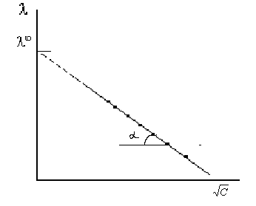
Fig.4. Dependence${ λ}_{C}=ʄ(\sqrt{C})$ for strong electrolytes

For weak electrolytes, this method is not applicable, since their complete dissociation is achieved only at low concentrations: it is inconvenient to work with such solutions (Fig. 5).

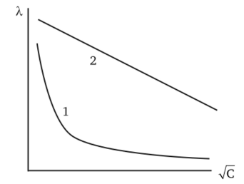

Fig.5. Dependence${ λ}_{C}=ʄ\left(\sqrt{C}\right):$ for 1 – strong electrolyte,
2 – weak electrolyte

The value of λ∞ for weak electrolytes can be approximately calculated using the Ostwald-Walden rule, according to which

$λ_{∞}=λ_{C}+{nB}_{C}$ (18)

where n is product of the valency of an anion and a cation;
В_{С} is constant depending on electrolyte concentration.

The dependence of the value of B_{C} on the concentration of the solution is shown below:

1/С, l/g-eq | 32 | 64 | 128 | 256 | 512 | 1024
В_{С} | 13 | 10 | 8 | 6 | 4 | 2.5

For weak electrolytes, the value of λ∞ is also determined using the Kohlrausch law (12), if the equivalent electrical conductivities of ions at infinite dilution are known from tabular data.
These values are most often given for a temperature of 25 ºC (18 ºC), therefore, before using them, it is necessary to recalculate, adjust for the temperature of the experiment, according to formula (15).
Having calculated the values of λ∞ and λ for a weak electrolyte using equation (14), we can calculate its degree of dissociation using the Ostwald dilution law:

$K_{D}=\frac{α^{2}C}{1-α}$ (19)

Having determined its dissociation constant in terms of electrical conductivities:

$K_{D}=\frac{λ^{2}C}{λ_{∞}(λ_{∞}-λ_{С})}$ (20)

Since for weak electrolytes α << 1, then from equation (19) К_{D} = α²С, whence

$α=\sqrt{\frac{K}{C}}=\frac{λ}{λ_{∞}}$ (21)

It follows from the last relation that λ=λ∞$\sqrt{\frac{К}{С}}$, and in the logarithmic form this dependence has the following form:
lgλ = lg$λ_{∞}+\frac{1}{2}lgK_{D}-\frac{1}{2}lgC$ (22)

Since for weak electrolytes λ∞ and K_{D} are constant values, then the dependence graph lgλ = f(lgC) will be linear with a slope equal to $\frac{1}{2}$. Equation (20) can be transformed and presented as:

$\frac{1}{λ}=\frac{1}{λ_{∞}}+\frac{λC}{Kλ_{∞}^{2}}$ (23)

And then the dependence$\frac{1}{λ}$=f($λ$C) will be expressed as a straight line with the slope tangent equal to $\frac{1}{Кλ_{∞}^{2}}$.

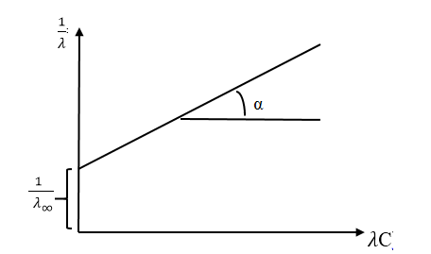

The value of λ∞ is found by extrapolating a linear dependence to zero concentration, and K_{D} is calculated using the equation:

$K_{D}=\frac{tgα}{λ_{∞}^{2}}$ (24)

The ratio of the equivalent electrical conductivity of strong electrolytes at a given concentration to a certain electrical conductivity is called the electrical conductivity coefficient f_{λ} and reflects the interionic interaction:

$f_{λ}=\frac{λ}{λ_{∞}}=\frac{λ^{+}+λ^{-}}{λ_{∞}^{+}+λ_{∞}^{-}}$ (25)

The value of f_{λ} depends on the charge of the ions: for a one-univalent (1-1) electrolyte in a 0.1 n solution f_{λ} ≈ 0.8, for one-two-valence (1-2) is f_{λ} ≈ 0.75, for two-two-valence (2-2) is f_{λ} ≈ 0.4. For strong electrolytes, λ∞ can be calculated by extrapolating the dependence λ=f($√С$) to С = 0, from the equation of the second Kohlrausch laws:
$λ=λ_{∞}-A\sqrt{C}$ (16)

For a binary 1-1-valence electrolyte in dilute solutions, the constant A in equation (16) is, according to the Debye-Hückel-Onsager theory, the sum of the electrophoretic A_{e} and relaxation A_{r} effects of inhibition: A = A_{e} + A_{r} . λ∞ and equation (16) can be written:

$λ=λ_{∞}-(A_{э}+A_{p}λ_{∞})\sqrt{C}$ (26)

which is known as the Onsager equation:

$A_{э}=\frac{82.4}{{(ξT)}^{1/2}η}$ (27)

$A_{p}=\frac{{8.2×10}^{5}}{{(ξT)}^{3/2}}$ (28)

where ξ –is the dielectric constant of the solvent;
η is the viscosity of the medium at temperature T, K.
The specific and equivalent (molar) electrical conductivity play an important role in electrochemical systems. The electrical conductivity of electrolyte solutions is measured using a Kohlrausch bridge powered by alternating current of high frequency, the device of which is described in detail in all workshops on physical chemistry /3,4/.

3. OPERATING PROCEDURE

Equipment and materials: 0.1 M solutions of potassium chloride, sodium nitrate, ammonium chloride, hydrochloric acid, sodium hydroxide, etc., bidistilled water, conductometer for measuring electrical conductivity.
Prepare five strong electrolyte solutions in the concentration range from 0.1 to 0.001 M. Measure the electrical conductivity of the solutions, starting with the solution with the lowest concentration.

- RESULTS PROCESSING

- Calculate the equivalent electrical conductivity of the electrolytes under study: $λ_{C}=\frac{χ}{C_{i}}×1000$.
- The results of determination of the dependence of specific electrical conductivity and the calculated values of equivalent electrical conductivity on concentration should be presented graphically in the coordinates χ = f(С) and λС = f(С) and explain the dependences.
- For a strong electrolyte, determine graphically the limiting equivalent electrical conductivity λ∞ using the equation: $λ_{C}=λ_{∞}-A\sqrt{C}$ ( λ_{С} = f($\sqrt{с}$)) and compare the obtained data with the reference data.
- For a weak electrolyte, determine the limiting equivalent electrical conductivity λ∞ using the Kohlrausch equation: $λ_{∞}=λ_{k,∞}+λ_{a,∞}$. Take the equivalent electrical conductivity of ions at infinite dilution from the tabular data.
- For a weak electrolyte, determine the average value of the degree of dissociation: $α=\frac{λ_{C}}{λ_{∞}}$ and the average value of the dissociation constant:
$K_{D}=\frac{λ^{2}C}{λ_{∞}(λ_{∞}-λ_{С})}$ and compare the obtained data with reference data.

- SAFETY PRECAUTIONS

In the process of work performance, it is prohibited to:
1. Turn the equipment on and off without the teacher's permission.
2. Leave the equipment, which is energized, unattended.
3. Work with ungrounded equipment.
When performing laboratory work student must:
• work in a lab coat, if necessary, use personal protective equipment;
• work carefully, keep cleanliness;
• drain waste solutions into drain containers specially designed for this purpose;
• handle chemical glassware, reagents, equipment with care;
• perform the work in the described sequence.

- REQUIREMENTS FOR THE REPORT

The report should contain the following sections:
- Aim of the work.
- Intermediate and final results of experiments.
- Results processing calculations.
- Conclusion based on the results of experiments and calculations.
- The work must be signed by the student and teacher.

- control questions

- What are relaxation and electrophoretic effects?
- What is the physical meaning of electrical conductivity, its dimensions, dependence on concentration and temperature?
- What is the physical meaning of equivalent electrical conductivity, its dimensions, dependence on concentration and temperature?
- Formulate the Kohlrausch law of independent motion of ions.
- How to determine the limiting electrical conductivity for strong and weak electrolytes?
- What is the mobility and absolute rate of ions?
- How to determine the dissociation constant of a weak electrolyte?
- The law of active masses. Degree of dissociation, dissociation constant, Ostwald dilution law.
- Explain the Onsager equation.

- rECOMMENDED LITERATURE
- Семченко Д.П., Стромберг А.Г. Физическая химия.- М.: Высш. шк., 2000.- 512 с.
- Практикум по физической химии / Под ред. В. В. Буданова, Н.К. Воробьёва. - М.:Химия, 2000. – 387 с.
- Дамаскин Б.Б., Петрий О.А., Цирлина Г.А. Электрохимия. М.: Химия, Колос, 2006, 672 с.
- Практические работы по физической химии: Учеб. пособ. для вузов / Под ред. К.П. Мищенко, А.А. Равделя, А.М. Пономаревой.- СПб, изд-во «Профессия», 2002. – 384с.
- Краткий справочник физико-химических величин /Под ред. А.А. Равделя, А.М.Пономаревой. - М.: Химия, 2002. - 327 с.
- Киселева Е.В., Каретников Г.С., Кудряшов И.В. Сборник примеров и задач по физической химии.- М.: Высш. шк., 2001. – 389 с.

ANNEX

Table 1

Equivalent electrical conductivity of ions (mobility) at infinite dilution, T = 20⁰C

Ion | λ₀, Ohm⁻¹cm²mol⁻¹
H+ | 324.92
Na⁺ | 45.38
K+ | 67.14
½ Ba²⁺ | 63.60
½ Ca²⁺ | 59.50
½ Mg²⁺ | 53.00
OH⁻ | 178.80
CH₃COO⁻ | 36.68
Cl⁻ | 68.96
½SO ²⁻  4 | 71.72
½CO ²⁻  3 | 69.30

Table 2

Specific electrical conductivity of solutions for determination of the vessel constant, T = 25⁰C

С, mol/l | æ, Ohm⁻¹cm⁻¹
 | KCl | NaCl
0.0200 | 0.0027670 | 0.0023150
0.0100 | 0.00144130 | 0.0011850
0.0050 | 0.0007177 | 0.0006032
0.0025 | 0.0003553 | 0.0003001
0.0010 | 0.0001469 | 0.0001237

